

UNIVERSITI MALAYSIA TERENGGANU

**Faculty of Computer Sciences and Mathematics Web Based Application Development**

**CSM3023**

Lab Report 2

**Prepared for:**

Sir. Mohd Arizal Shamsil bin Mat Rifin

**Prepared by:**

Muhammad Amir Fakhrie Bin Mohd Zamrie (S65453)

3rd April 2024

Bachelor of Computer Science (Mobile Computing) with Honors

Semester II 2023/2024

# Task 1 : Data Sharing in Servlet

* Objective: To use servlet for request forwarding and data sharing by writing a login form and a servlet to authenticate a user.

Output:

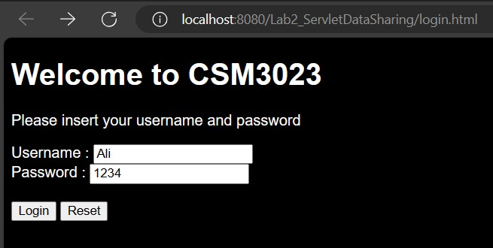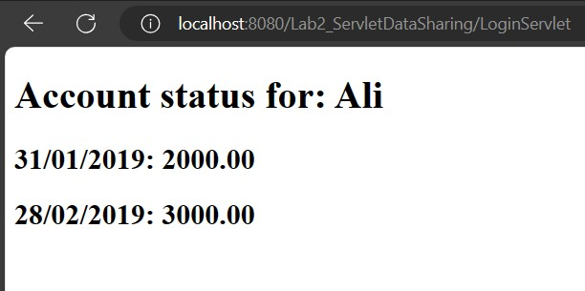

* Reflection:
  1. What have you learnt from this exercise?

From this exercise I learnt how to use a servlet for request forwarding and data sharing to authenticate a user in a login form. An HTML form was created for user input, which collects the username and password. This form submits data to a LoginServlet for processing. The servlet retrieves the username and password submitted from the HTML form, validates them against a predefined set of credentials stored in a HashMap, and forwards the request accordingly.

* 1. What are the common methods used in Java Servlet?
     + doGet()
     + doPost()

# Task 2 : Creating A Table in MySQL Database

* Objective: To create a MySQL table to store user credentials by preparing a user table to be used in Web Application.
* Output:

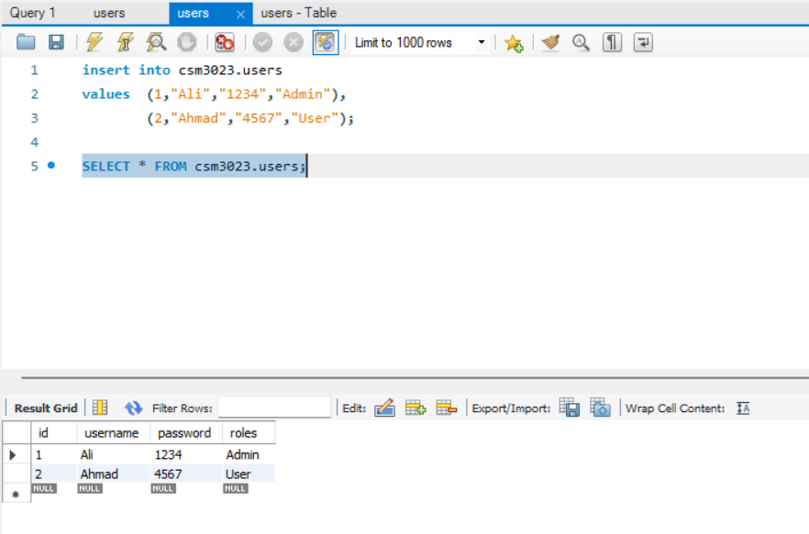

# Task 3 : Setting The Environment of Web Application for Database Connection

* Objective: To set up a proper environment for integrating web application to the database by importing MySQL JDBC Library to an existing project.
* Output:

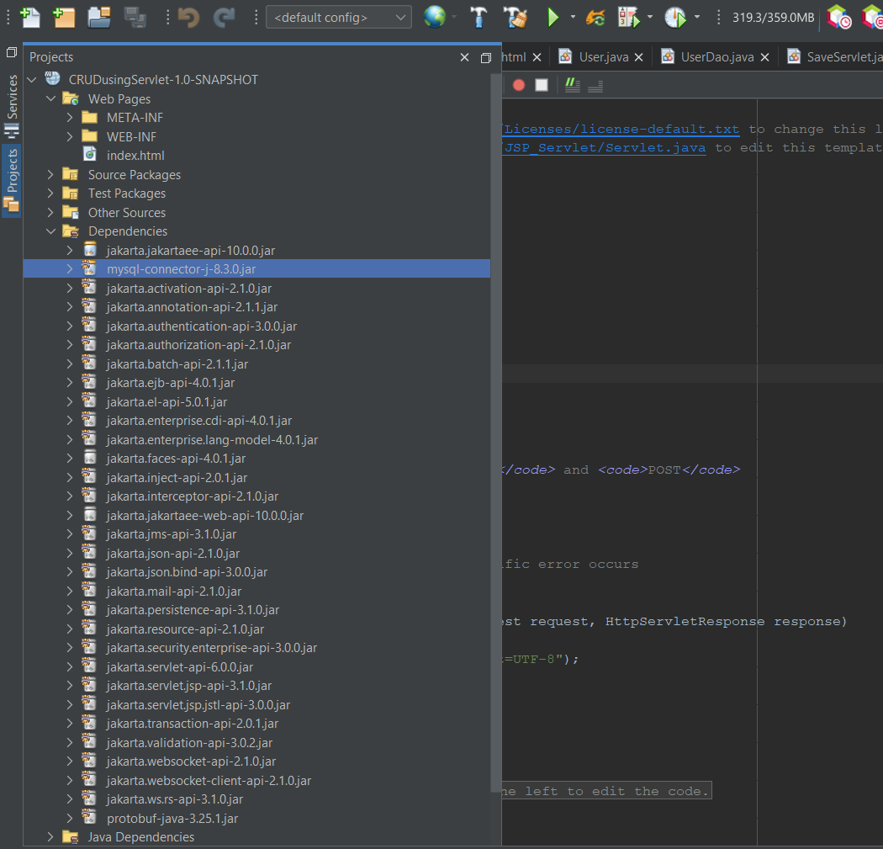

**Task 4 : Using Servlets for Database CRUD Operations**

* Objective: To program multiple servlets for manipulating the database by programming five different servlets to handle database operations such as insert, update and delete.

Output:

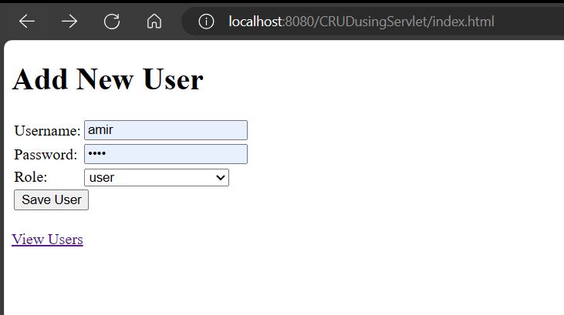

* Reflection:

1. What is the name of the Java Library that you need to import before coding the web application with database operations?

The name of the Java library commonly used for database operations in web applications is JDBC (Java Database Connectivity). JDBC provides a set of classes and interfaces for accessing and manipulating relational databases from Java

programs. It allows Java applications to connect to a database, send SQL queries, retrieve results, and perform database transactions.

1. Which folder keeps the web.xml file? Copy the contents of the file and explain in brief the tags included such as <servlet-name> <servlet-class> <servlet-mapping>. etc.

The web.xml file is located in the WEB-INF folder of a Java web application.

<?xml version="1.0" encoding="UTF-8"?>

<web-app version="6.0" xmlns="https://jakarta.ee/xml/ns/jakartaee" xmlns:xsi="[http://www.w3.org/2001/XMLSchema-instance"](http://www.w3.org/2001/XMLSchema-instance) xsi:schemaLocation="https://jakarta.ee/xml/ns/jakartaee https://jakarta.ee/xml/ns/jakartaee/web-app_6_0.xsd">

<servlet>

<servlet-name>SaveServlet</servlet-name>

<servlet-class>SaveServlet</servlet-class>

</servlet>

<servlet>

<servlet-name>ViewServlet</servlet-name>

<servlet-class>ViewServlet</servlet-class>

</servlet>

<servlet>

<servlet-name>EditServlet</servlet-name>

<servlet-class>EditServlet</servlet-class>

</servlet>

<servlet>

<servlet-name>EditServlet2</servlet-name>

<servlet-class>EditServlet2</servlet-class>

</servlet>

<servlet>

<servlet-name>DeleteServlet</servlet-name>

<servlet-class>DeleteServlet</servlet-class>

</servlet>

<servlet-mapping>

<servlet-name>SaveServlet</servlet-name>

<url-pattern>/SaveServlet</url-pattern>

</servlet-mapping>

<servlet-mapping>

<servlet-name>ViewServlet</servlet-name>

<url-pattern>/ViewServlet</url-pattern>

</servlet-mapping>

<servlet-mapping>

<servlet-name>EditServlet</servlet-name>

<url-pattern>/EditServlet</url-pattern>

</servlet-mapping>

<servlet-mapping>

<servlet-name>EditServlet2</servlet-name>

<url-pattern>/EditServlet2</url-pattern>

</servlet-mapping>

<servlet-mapping>

<servlet-name>DeleteServlet</servlet-name>

<url-pattern>/DeleteServlet</url-pattern>

</servlet-mapping>

<session-config>

<session-timeout> 30

</session-timeout>

</session-config>

</web-app>

<servlet-name> specifies a unique name for the servlet configuration. <servlet- class> specifies the fully qualified class name of the servlet implementation.

<servlet-mapping> maps a servlet to a URL pattern. It defines the URLs that invoke the servlet. <url-pattern> specifies the URL pattern to which the servlet is mapped.

1. Define the usage of Data Access Object (DAO) servlet. How it eases the business process in your servlet-based web application?

A Data Access Object (DAO) servlet is a design pattern used to separate the data access logic from the business logic of a servlet-based web application. The DAO pattern involves creating a separate class or set of classes responsible for interacting with the database, querying data, and performing database operations. By using a DAO servlet, the business logic in servlets can focus on handling user requests, processing data, and generating responses, while the data access logic is encapsulated within the DAO classes, improving the overall organization and clarity of the application architecture.